# RECIPE SHARING PLATFORM

### A MINI PROJECT REPORT

#### Submitted by

#### Group/Team No: G13/PG2

**PARVESH, 2310991011**

**PARTH SIDNA, 2310991010**

**PERAVEL SHARMA, 2310991012**

#### in partial fulfillment for the award of the degree of

## BACHELEOR OF ENGINEERING

***in***

COMPUTER SCIENCE & ENGINEERING



**CHITKARA UNIVERSITY**

**CHANDIGARH-PATIALA NATIONAL HIGHWAY**

**RAJPURA (PATIALA) PUNJAB-140401 (INDIA)**

##### DECEMBER & 2023

##### INDEX

|  |  |  |  |  |  |
| --- | --- | --- | --- | --- | --- |
| S.NO |  |  | CONTENT | PAGE NO. | SIGNATURE |
| 1 |  |  | INTRODUCTION |  |  |
| 2 |  |  | ABOUT WEB TECHNOLOGY |  |  |
| 3 |  |  | OBJECTIVES |  |  |
| 4 |  |  | TECHNOLOGIES USED |  |  |
| 5 |  |  | PROCEDURE |  |  |
| 6 |  |  | WORKING |  |  |
| 7 |  |  | DATA FLOW DIAGRAM |  |  |
| 8 |  |  | BIBLOGRAPHY |  |  |

**INTRODUCTION**

The purpose of the document is to analyze and track the requirements of a recipe repository system, which is going to be a web-based application to archive and retrieve recipes of any kind from a pool of ingredients and recipes. It aims to outline the complete description of the system.

The recipe repository system, which is a web-based application, aims to meet following requirements within the system:

• Archiving the recipes of any kind on the system dynamically where the authorization of the moderator is required

• If the category of the recipe is not available on the system, user should cerate it after the confirmation of the moderator

• After the insertion of the recipe details by the user, moderator should check the details and confirm the recipe

• While inserting recipes, the system should provide some shortcuts and clarifications

• Within the system, an ingredient may also be a recipe rather than a defined ingredient

• In order to retrieve a recipe, the system is advised to use a search through all the branches

• There will be parts for the alternatives, advices and comments for the recipe from the author

• It should be possible to retrieve a recipe through searching its name, ingredients, keywords and so on

• The results of the queries narrowed down with the filters are listed in a sorted manner by the percentage.

Key Features:

* Effortless Recipe Search:

An intuitive search engine allowing users to explore an extensive collection of recipes based on ingredients, cuisine, cooking time, and difficulty level.

* User-Friendly Recipe Submission:

A streamlined recipe submission process, empowering users to effortlessly share their culinary creations with the Recipe Hub community. Users can add detailed instructions, ingredients, and visually appealing images.

* Personalized Profiles:

Users can create personalized profiles to showcase their culinary expertise, preferences, and achievements. Customize your experience by setting dietary preferences and cooking style.

* Interactive Community Engagement:

Social features including likes, comments, and shares to facilitate interaction and feedback among users. Engage in lively discussions, share tips, and celebrate each other's culinary triumphs.

* Dynamic Rating and Review System:

A robust rating and review system enabling users to provide feedback, helping others identify top-rated recipes and culinary gems within the vast Recipe Hub collection.

* Cookbook Compilation:

Users can curate their favorite recipes into personalized cookbooks, making it easy to organize and revisit their most-loved dishes. Share these cookbooks with the community or keep them private.

* Responsive Design:

A mobile-responsive interface ensures that Recipe Hub is accessible anytime, anywhere, allowing users to engage with the platform seamlessly from their devices.

* Advanced Filtering Options:

Fine-tune recipe searches with advanced filtering options, such as dietary restrictions (vegan, gluten-free), occasions (festive, weeknight dinner), and specific kitchen tools required.

* Ingredient Substitution Suggestions:

Integrate a feature that suggests ingredient substitutions, catering to users with dietary restrictions or those looking for creative alternatives based on availability.

* User-Generated Content Spotlight:

Highlight a "Recipe of the Week" or feature user-generated content to celebrate and showcase exceptional recipes from the community, fostering a sense of recognition and appreciation.

Benefits:

Recipe Hub is not just a repository; it's a community-driven platform fostering a love for cooking and culinary exploration. Whether you're a novice cook seeking inspiration or a seasoned chef looking to share your expertise, Recipe Hub is the go-to destination. Join us in creating a flavorful, diverse, and collaborative culinary community at Recipe Hub—where every dish tells a story, and every user contributes to the shared joy of cooking. Explore, share, and savor the richness of Recipe Hub.

* Collaborative Cooking Events:

Facilitate virtual cooking events and challenges where users can participate, share their creations in real-time, and learn from each other. This fosters a sense of community and camaraderie.

* Educational Resources:

Provide educational resources such as cooking tips, techniques, and articles written by culinary experts. Empower users to enhance their cooking skills and knowledge.

* Shopping Integration for Direct Purchase:

Collaborate with online grocery platforms to enable users to directly purchase ingredients for a recipe through the Recipe Hub interface, streamlining the cooking process.

**WEB TECHNOLOGY**

Web technology is a term used to describe all the different things people use to make websites and web-based applications. This includes software and hardware tools, programming languages, and standards needed to create and run web apps on the internet. Web technology comprises many areas, including web design, web development, web servers, web browsers, e-commerce, and content management systems.

The goal of web technology is to make web-based applications work better, faster, and more enjoyable for people to use. It's always changing and improving, so we can make the most out of the internet and all the great things it offers.  
  
Classification of Web Technology are:

* **World Wide Web (WWW):**It enables users to browse and access information through web browsers.
* **Web servers:** They process requests and send responses to web browsers
* **Web browsers:** They are the tools we use to look at web pages
* **HTML:**It's a language that helps structure and show content on web pages
* **CSS:** It helps make web pages look pretty by adding colors, fonts, and styles
* **JavaScript:** It's a language that makes web pages do cool stuff like animations and interactive features
* **Backend Technologies:**They are the tools used to make the server-side parts of web apps work
* **Database Systems:** They store and retrieve data used in web apps

## Importance of web technology

Here are some key points highlighting the importance of web technology:

1. **Global Reach:** The Internet and web technology allow businesses to reach a worldwide audience with their products and
2. services.
3. **Cost-Effective:** Web technology enables businesses to reduce costs by automating processes, improving efficiency, and reducing the need for physical infrastructure.
4. **Improved Communication:** Web technology facilitates communication and collaboration across organizations and geographies, enabling better knowledge sharing and decision-making.
5. **Enhanced Customer Experience:** Web technology allows businesses to provide a more personalized, interactive, and engaging customer experience.
6. **Access to Data:**Web technology provides vast amounts of data that can be used for analysis, insights, and informed decision-making.
7. **Mobile Access:**Web technology enables businesses to reach customers through mobile devices, which have become increasingly important in people's lives.
8. **Innovation:**Web technology drives innovation by providing a platform for new products, services, and business models.
9. **Social Impact:**Web technology can improve social and economic outcomes by providing access to education, healthcare, and other essential services.

OBJECTIVE

Most of the recipe sharing applications contain only those recipes specified by a cook and is uploaded by the admin. The users are allowed to browse and view the recipes. The present application does not allow any researcher to obtain a survey report based on the age group and professions. The present application does not clearly provide proper remedies for a disease interms of the type of food he/she should intake.

* Create a Centralized Hub: Establish a user-friendly platform that serves as a centralized hub for storing, accessing, and sharing a diverse collection of recipes.
* Facilitate Culinary Exploration: Encourage users to explore and experiment with a wide range of cuisines, cooking styles, and ingredients.
* Promote Community Engagement: Foster a vibrant and interactive community where users can connect, share their culinary experiences, and support each other's cooking journeys.
* Simplify Recipe Discovery: Develop robust search and filtering mechanisms to make it easy for users to discover recipes based on preferences, dietary needs, and available ingredients.
* Encourage User Contributions: Motivate users to contribute their own recipes, fostering a collaborative environment that celebrates the diversity of cooking styles and cultural influences.
* Enhance Learning: Provide educational resources, cooking tips, and techniques to empower users to improve their culinary skills and knowledge.
* Enable Personalization: Allow users to create personalized profiles, customize their preferences, and curate collections of favorite recipes.
* Ensure Accessibility: Implement features that make the platform accessible to users with diverse needs, including those with disabilities or different language preferences.
* Create a Visual Experience: Enhance the platform with visually appealing images and videos to make the cooking process more engaging and inspiring.
* Offer Social Integration: Integrate with social media platforms to enable seamless sharing of recipes, fostering a broader community reach and interaction.
* Implement Rating and Review System: Establish a robust system for users to rate and review recipes, providing valuable feedback and helping others make informed choices.
* Organize Cooking Challenges: Host regular cooking challenges and events to stimulate user participation, creativity, and friendly competition within the community.
* Support Multiple Devices: Ensure the platform is accessible and functional across various devices, including desktops, tablets, and smartphones.
* Integrate Shopping Features: Collaborate with grocery platforms to facilitate direct ingredient purchases, streamlining the cooking process for users.
* Promote Healthy Cooking Practices: Showcase recipes that align with health and wellness goals, providing nutritional information and encouraging mindful eating.
* Celebrate Culinary Diversity: Highlight regional and international cuisines, promoting cultural exchange and appreciation through the sharing of traditional recipes.
* Reward User Engagement: Implement a gamification system with badges, achievements, and rewards to recognize and incentivize active community members.
* Facilitate Virtual Cooking Classes: Organize virtual cooking classes and demonstrations led by experienced chefs or community members, offering users interactive learning opportunities.
* Integrate Smart Home Devices: Explore integration with smart home devices to provide users with a seamless and technologically advanced cooking experience.
* Gather User Feedback for Improvement: Regularly solicit user feedback through surveys and forums to identify areas for improvement, ensuring the continuous evolution and enhancement of the platform based on user needs.

Hypertext Markup Language (HTML):

HTML is the standard markup language for creating web pages.

* Text-Based Structure:

It uses a text-based approach, employing tags to structure content on the web.

* Tag System:

HTML consists of tags enclosed in angle brackets, indicating the beginning and end of elements.

* Document Structure:

Documents begin with <!DOCTYPE html> and have a standard structure with <html>, <head>, and <body> elements.

* Semantic Elements:

HTML5 introduced semantic elements like <article>, <section>, <header>, and <footer> for better document structure.

* Hyperlinks:

Hyperlinks are created with the <a> tag, enabling navigation between pages and resources.

* Images:

Images are embedded using the <img> tag with the src attribute pointing to the image file.

* Lists:
* Lists are created with <ul> (unordered), <ol> (ordered), and <li> (list item) tags.
* Headings:

Headings range from <h1> to <h6>, indicating different levels of importance.

* Paragraphs:

Paragraphs are defined by the <p> tag.

* Forms:

User input is facilitated through forms, created with the <form> tag, containing elements like <input>, <textarea>, and <select>.

* Attributes:

Elements may have attributes (e.g., class, id, src) that provide additional information or functionality.

* Document Metadata:

Metadata is set in the <head> section, including the page title, character encoding, and linked stylesheets.

* Multimedia Embedding:

Multimedia elements like audio and video are embedded using <audio> and <video> tags.

* Responsive Design:

HTML supports responsive design through the use of the viewport meta tag and media queries.

* Commenting:

Comments are added using <!-- --> to provide notes within the HTML code.

* Validation:

Valid HTML adheres to W3C standards, ensuring proper rendering across browsers.

* Accessibility:

HTML5 introduces accessibility features, aiding users with disabilities through semantic elements and ARIA attributes.

* Integration with CSS and JavaScript:

HTML seamlessly integrates with Cascading Style Sheets (CSS) for styling and JavaScript for interactivity.

* Evolution with HTML5:

HTML5, the latest version, introduces new semantic elements, APIs, and improved support for multimedia, enhancing the capabilities of web development.

Cascading Style Sheets (CSS):

CSS is a style sheet language used to describe the presentation of a document written in HTML or XML.

Styling Web Pages:

CSS is employed to control the layout, appearance, and design of web pages, allowing separation of content and presentation.

* Selectors and Declarations:

CSS uses selectors to target HTML elements and declarations to define their styles.

* Property-Value Pairs:

Declarations consist of property-value pairs, specifying aspects like color, font size, margin, padding, etc.

* Style Rule Syntax:

A style rule is formed by combining a selector and a set of declarations, enclosed in curly braces.

* Internal and External Styles:

Styles can be defined internally within an HTML document using the <style> tag or externally in a separate CSS file linked to the HTML.

* Box Model:

CSS employs the box model, consisting of content, padding, border, and margin, influencing the layout of elements.

* Flexbox and Grid Layout:

CSS provides layout models like Flexbox and Grid for advanced control over the arrangement of elements.

* Media Queries:

Media queries enable responsive design by adjusting styles based on characteristics such as screen size, resolution, or device orientation.

**JavaScript:**

JavaScript is a versatile scripting language primarily used for enhancing interactivity on web pages.

Client-Side Scripting:

Executed on the client's browser, enabling dynamic and real-time changes to web pages.

Object-Oriented:

JavaScript is an object-oriented language, allowing the creation and manipulation of objects.

Event-Driven Programming:

It follows an event-driven paradigm, responding to user actions such as clicks, input, or page loads.

Syntax Similarities:

Its syntax shares similarities with Java and C, making it accessible for developers familiar with these languages.

* Data Types:

Supports various data types, including numbers, strings, arrays, and objects.

Variables and Constants:

Variables (var, let, const) store data, and constants hold values that don't change.

Functions:

Functions encapsulate reusable code, promoting modular and organized scripting.

* Control Flow:

Conditional statements (if, else) and loops (for, while) control the flow of program execution.

DOM Manipulation:

JavaScript interacts with the Document Object Model (DOM) to dynamically modify HTML and CSS.

* Asynchronous Programming:

Supports asynchronous operations with features like callbacks, promises, and async/await for handling non-blocking tasks.

Browser Object Model (BOM):

Manipulates browser features like history, location, and navigator through the Browser Object Model.

**PROCEDURE**

Use of Head Tag

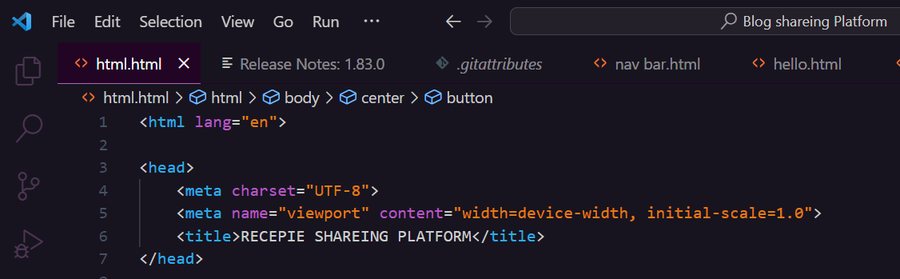

Use of Body Tag and Button tag with Link to other pages

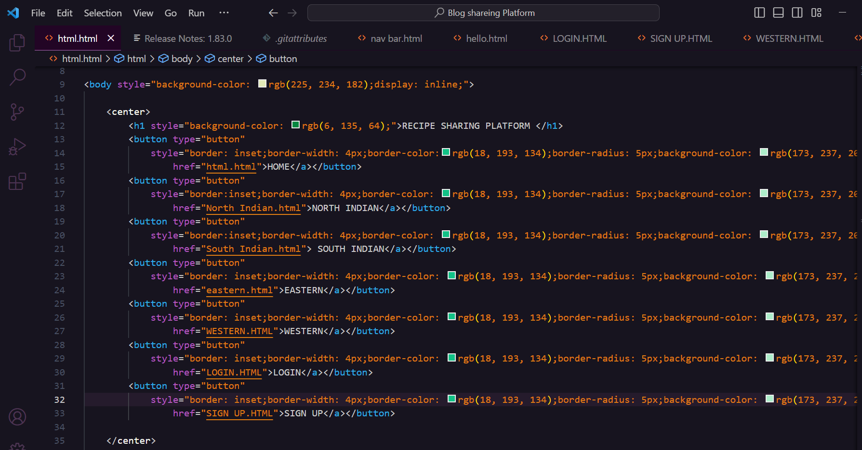

Use of Paragraph Tag

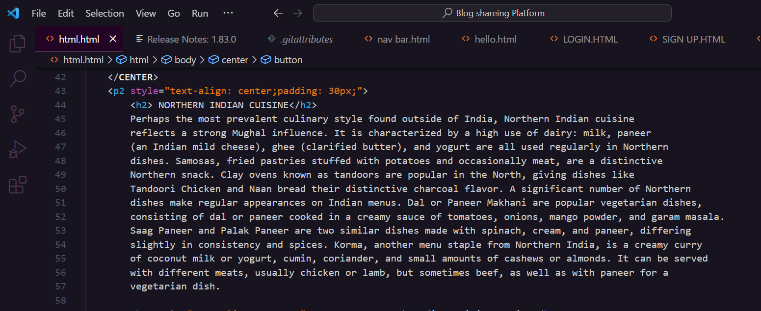

Use of Image tag with Href linking

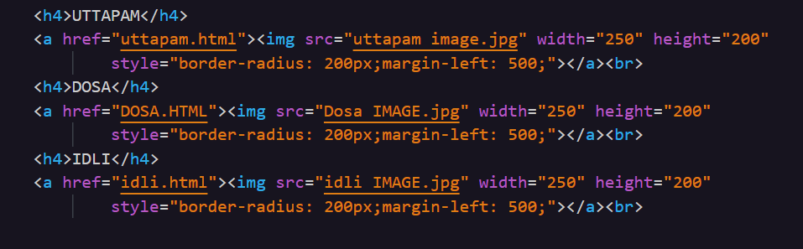

Login Form

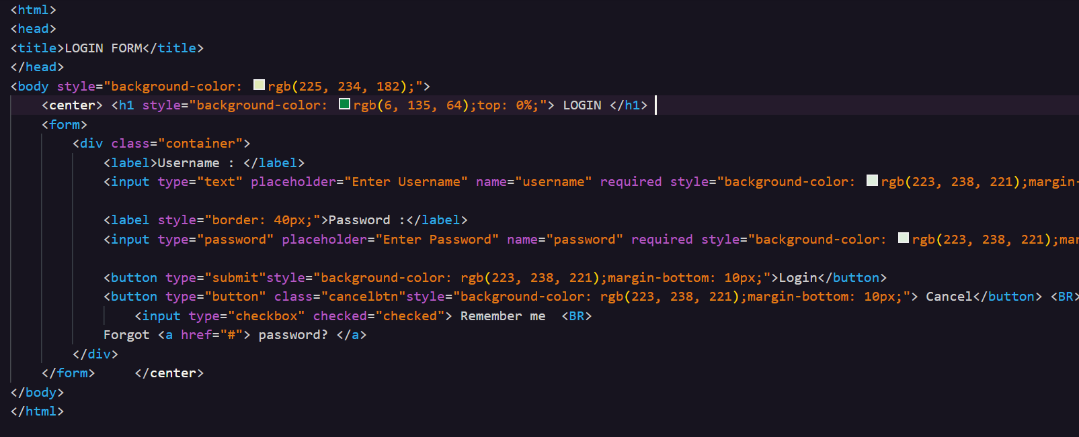

Sign Up Form

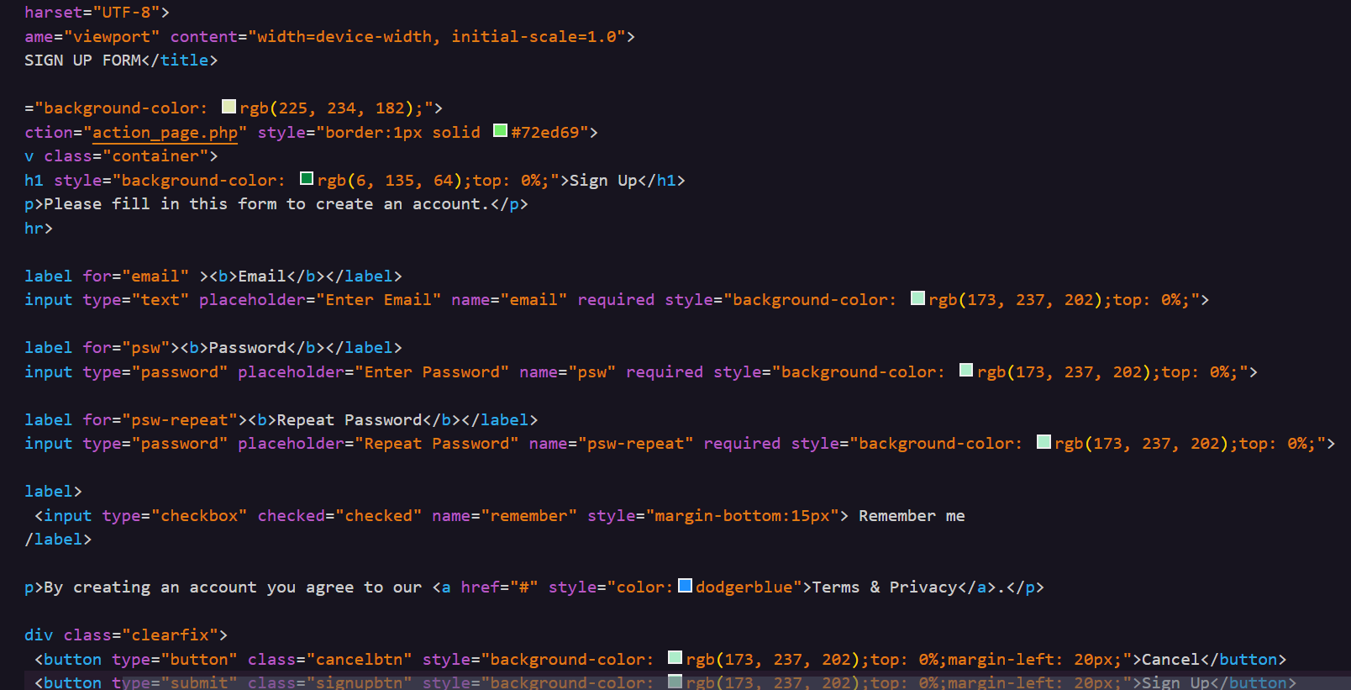

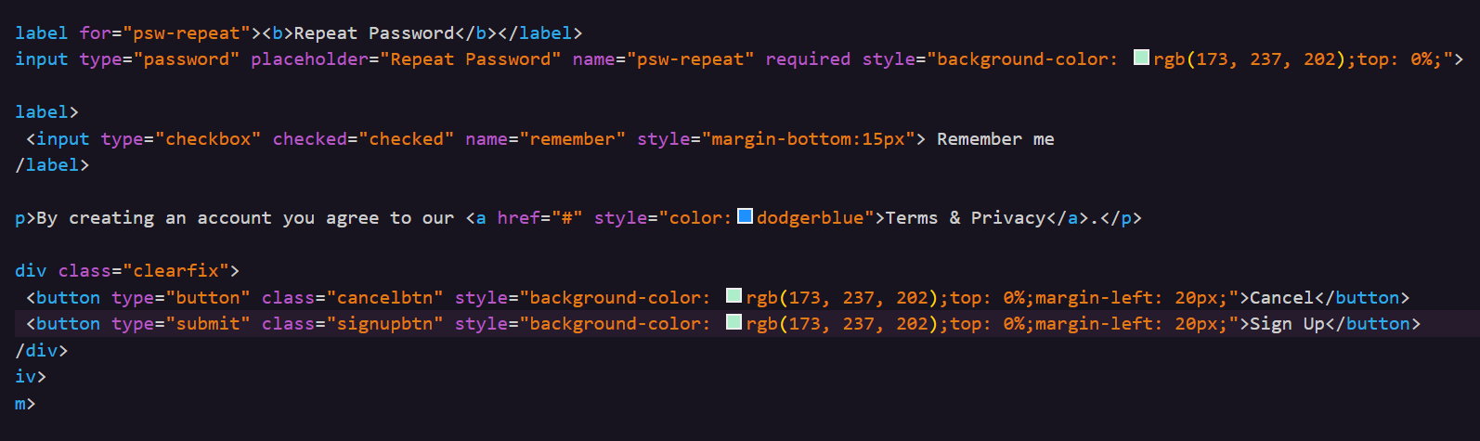

WORKING

